NORVIEW UMC
IN-PERSON WORSHIP PLAN
FINAL
October 22, 2020
In Person Worship in Sanctuary
Continue Worship on Facebook Live
Parking Lot Worship from FM transmitter 94.5 FM

This plan follows the requirements of the Virginia Conference of the United Methodist Church Technical Assistance Manual (TAM).

Sanctuary – In Person Worship
- Initial Cleaning
- All material except pianos, and permanent surfaces will be removed from the Sanctuary, (ie, hymnals, Bibles, envelopes, books, bulletins)
- Everything remaining in the sanctuary will be cleaned and wiped down with approved EPA or FDA cleaners or alcohol wipes and sprays that have 60% ethanol or 70% isopropanol. (ie, pews, chairs, tables, altar, floor, AV equipment)
- Sanctuary doors, door handles, light switches will be wiped down
- Signage for entrance, exit, safe distancing, mask and Health Acknowledgement Posters will be displayed.
- Once cleaned, the District Superintendent will be notified of the initial cleaning.

- Sunday Worship Cleaning
- Prior to the Sunday Service, the bathrooms will be cleaned and wiped down with EPA or FDA approved cleaners or cleaners with 60% ethanol or 70% isopropanol.
- Once clean the bathrooms will be closed until Sunday Morning Worship.
- During worship only one person can enter the bathroom at a time and they must wipe down each service that was used. The bathroom in the nursery/Children’s room will not be available for use.
- Wipe down all commonly touched surfaces, back of pews, handrails, door handles, AV equipment, and altar area.
- Once the Sanctuary is cleaned it will be closed until Sunday Worship.

- Personal Protective Equipment
- Anyone wishing to attend worship on Sunday should call the church office by Thursday noon so we can plan on the number coming.
- Church doors will be locked until 10:45, at which time registration will begin. Social distancing and marks are required while waiting to enter the church.
- Drop Off Offering will be available at the registration area.
- Everyone must wear a mask at all times and maintain safe social distancing of at least 6 feet when entering the building, in the building or leaving the building.
- When you enter the church, your temperature will be taken using an Infrared Non-contact thermometer, you must use the hand sanitizer provided, and you will be asked if you agree to the Health Acknowledgement Poster, and have the greeter place your name and telephone number on the register for that Sunday morning and given to the pastor to be locked up for contact tracing purposes if needed.
- If you have a temperature above 100.4 degrees, you will not be allowed to enter the church. Recheck temperature after 3-5 minutes due to infrared thermometer can be inaccurate.
- If you do not have a temperature, you will then be escorted to your seat by an usher when you enter the Fellowship Hall.

- Parking and Parking Lot Worshippers
- There will be a designated place for those who desire to listen to the service in your vehicle. A parking lot attendant will show you where to park. You must stay in your vehicle and cannot enter the church building.
- If you are entering the church for worship, you must leave a car space between each vehicle and wait to leave you vehicle until the person next to you is a safe distance away.
- Worshippers are to come straight to the church building from their vehicle, park as designated by attendant, and wait until the people in the car beside you are a safe distance away
- When leaving you are asked to go straight to your car and maintain a safe distance
- If you arrive later than 11:05, please stay in your car and listen to the service on the radio on FM 94.5. The doors of the church will be locked at 11:05.

- Seating in the Sanctuary
- The Sanctuary will be arranged to seat individuals and families safely distanced from one another
- If you cannot wear a mask for medical reasons, or if you feel sick, please stay home or listen in your car.
- Children who cannot keep a mask on are asked to remain at home. The American Association of Pediatrics guidance is that children under 2 years of age should not wear a face covering. Therefore, children under two cannot attend an in-person worship service.
- Families with children who can wear a face covering will be asked to sit in the back pews. If the child will not keep their mask on, the parent must take the child out of the service and cannot return.
- There will be no nursery or children’s church provided and no In-person Sunday School or Bible Study.

- If someone in worship is sick
- That person will be escorted to the D. W. Davidson Sunday School Room
- Everyone will be asked to go home and the Sanctuary will be cleaned after everyone leaves
- The person who is sick will leave the D. W. Davidson Classroom through the outside door
- The entrance, hallways and classroom will be cleaned after everyone leaves

- Additional Information
- There is no choir, special music, or congregational singing during the worship service at this time.
- Wind instruments cannot be played during the worship service at this time.
- If you cannot wear a mask due to a medical condition or you feel sick, please stay home
- If someone refuses to wear a mask and will not leave the service, the service will end and everyone will be sent home
- No food or drinks are allowed to be consumed at any time on church property and the water fountain will be shut off
- Except for the hallways to the bathrooms, the rest of the church building will be off limits to everyone except the church staff
- Communion and Baptisms will not be observed in the church building until we have moved into Phase 3 for in-person worship

- Entering and Exiting
- Worshipers will walk to the front entrance from the parking lot along the sidewalk on the left side of the church. They will maintain a safe distance of at least 6 feet and be wearing a mask.
- At the front entrance there will be a registration desk outside to have each person confirm with a yes, the Entranceway Health Acknowledgement Poster and have their name and phone number place on the registration form for that day.
- When entering the church, the usher will escort the parishioners to their seat starting with the front row next to the aisle and work their way filling the pews to the end of the last pew.
- When leaving the sanctuary following the service the parishioners will leave beginning with the first pew on the left side of the sanctuary, out the door on the left and go out the back door by the counting room. Each person will leave keeping a safe distance of at least 6 feet and go directly to their vehicles and leave the church property.
- Church members will not engage the staff or the pastor at this time.
- Ushers and Parking Lot Workers
- We will need an Usher, a Registration Person, and a Parking Lot
Worker for each Sunday Service.
- All workers must acknowledge the Entranceway Health
Acknowledgement Poster and be registered for that day’s
attendance.
- Each person must wear a mask and gloves, and maintain a safe
distance of 6 feet when doing their tasks.
- - If you are sick or cannot wear a mask and gloves, please stay home.
- - Let the church office know by Wednesday of your availability for Sunday Worship.
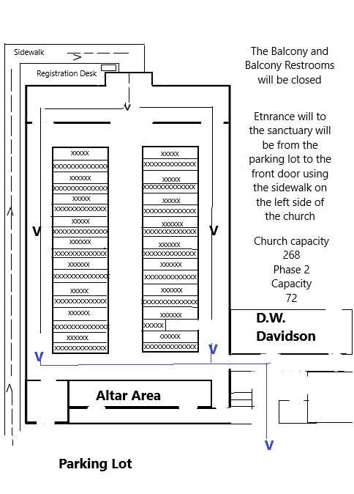
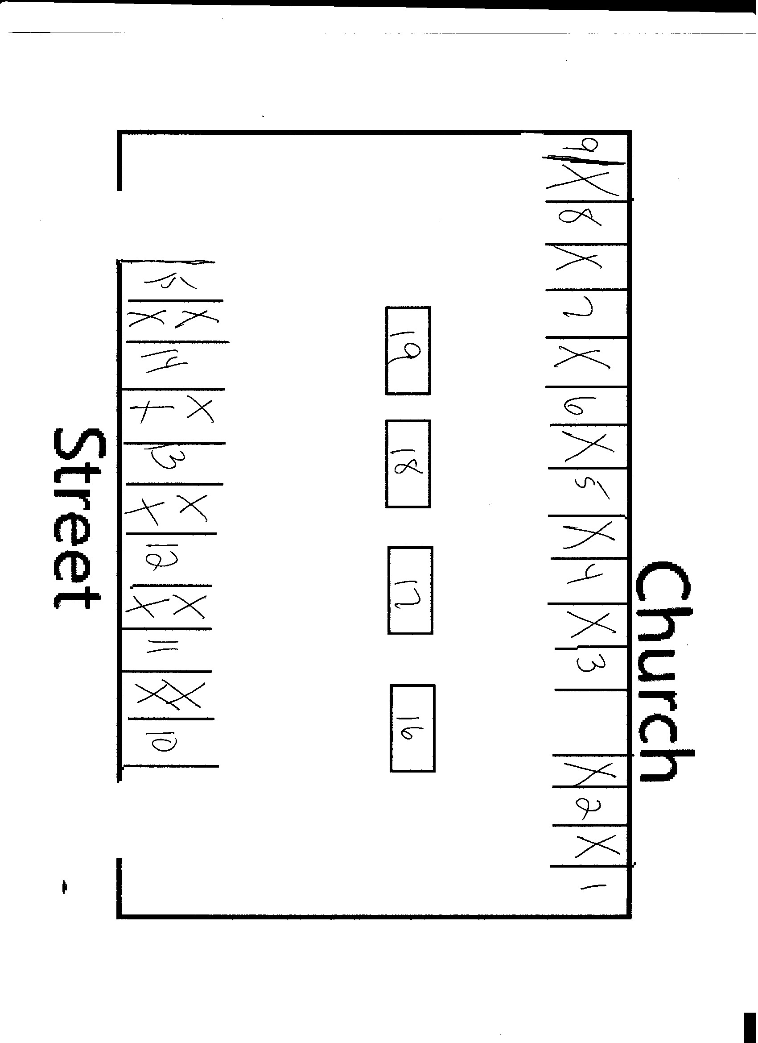

IN-PERSON NON-WORSHIP GATHERSING
(Civic League, AA, NA)
Each Group whether inside or outside group must agree to the requirements of this plan in order to use the church facilities.

- GENERAL INFORMATION
- Each Group must inform the church of their meeting schedule and be placed on the church calendar before they begin meeting at the church.
- Each group will meet in the Fellowship Hall and be limited to 50 people, including the leaders.
- There will be no food or drinks allowed during the meeting. Group members must wear a mask, observe safe distance of at least 6 feet at all times, including outside, in the building and when entering and leaving.
- If someone is sick they must stay home.
- Each person must agree to the Health Acknowledgement Poster once they agree they will give their name and phone number to be used for contact tracing if needed.
- A registration form listing everyone who attended the meeting with their name, phone number to be given to the pastor sealed in an envelope to be locked in a safe place for contact tracing purposes.

- CLEANING
- The Fellowship must be cleaned and wiped down using EPA or FDA approved cleaners or cleaners with 60% ethanol or 70% isopropanol prior to the group coming into the fellowship Hall.
- After the meeting any surfaces used or touched in the fellowship Hall should again be cleaned and wiped down, including the doors, hallway, entrance door and handrails.
- The rest of the church building is closed and should not be entered or used.

- THE DAY OF THE MEETING
- At the back entrance where the ramp beings a registration table will be set up. That person will have each member of the group acknowledge the Entranceway Health Acknowledgement Poster, each member should be wearing a mask, and their name and contact information recorded on the registration form to be given to the pastor for contact tracing if necessary.
- If anyone is sick, does not acknowledge the EHAP, will not wear a mask, or will not let them be registered with contact information, they cannot enter the church building.
- If someone takes their mask off during the meeting and refuses to put it back on, the meeting is ended and everyone must leave, and the Fellowship Hall cleaned as directed.

- IF SOMEONE GETS SICK DURING MEETING
- That person will be escorted to the D.W. Davidson Sunday School Room
- Everyone will be asked to go home and the Fellowship Hall will be cleaned after everyone leaves
- The person who is sick will leave the D.W. Davidson Classroom through the outside door
- The entrance, hallways and classroom will be cleaned after everyone leaves

- ENTERING AND LEAVING
- Each person will enter through the entrance near the kitchen with the ramp and enter the Fellowship Hall through the door in front of that entrance keeping at least 6 feet apart.
- When leaving the Fellowship Hall they are to use the door on the right, the opposite door and exit through the rear door next to the counting room.
- When arriving each person is to enter the building immediately keeping a safe distance of at least 6 feet. When leaving they must go directly to their vehicle and leave the church property.

